MARUKAN MEETING MINUTES MODULE QA TEST REPORT
No. | Section | QA Test Result | QA Comments | Reference | IT Comments
1 | Add New | Passed | Functional | - NA
2 | Meeting Details | Passed | “Select All” has been added to the list and is functional. | 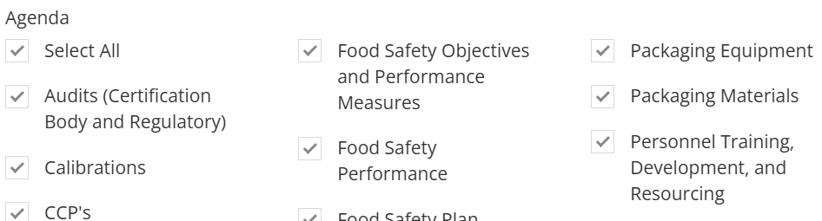
3 | Notes | Passed | Functional | NA
4 | Meeting Minutes Home Page | Failed | Agenda section does not reflect the Meeting Agenda selected | 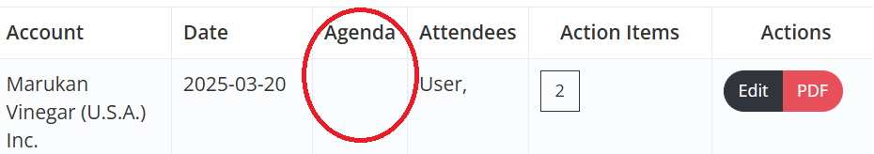
5 | Action Items Section | Passed | Functional | NA
6 | Action Section | Passed | For improvement: Add a delete option in case action items are entered by mistake. | 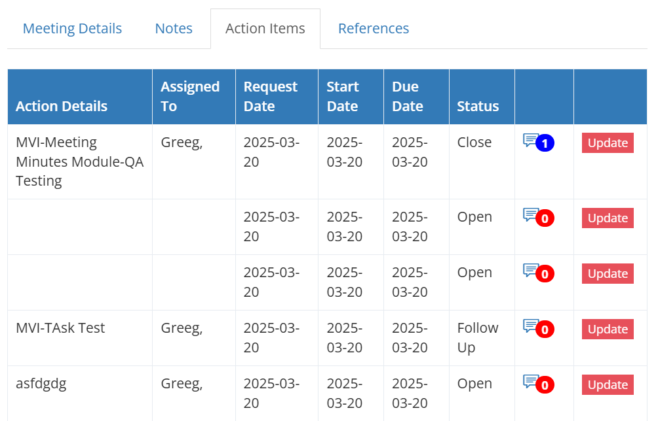
7 | Reference | Failed | Can attach files, images and videos but the attachments cannot be opened. | 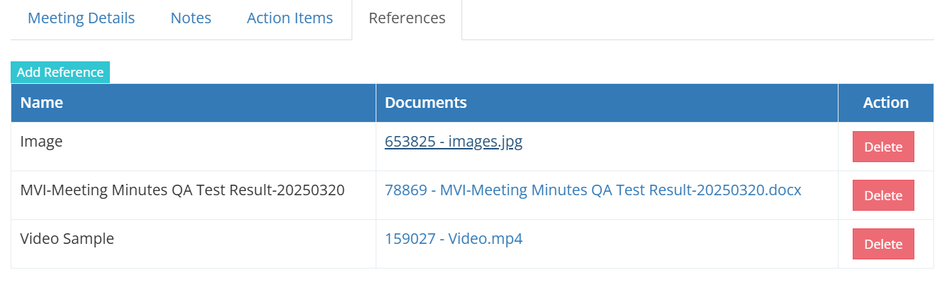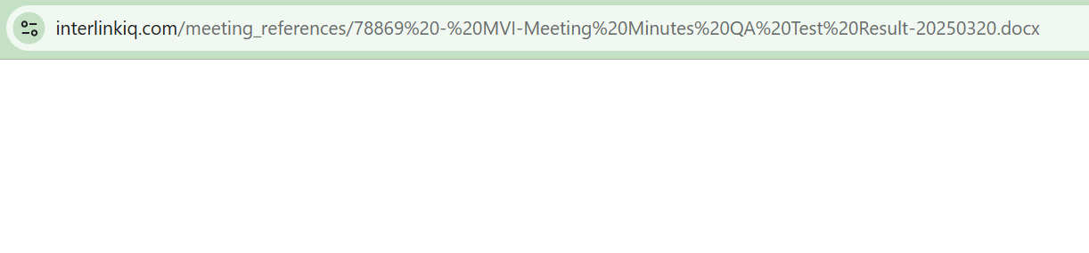
8 | Griffin Switch Account | Failed | Updates made in the Main Switch Account has been reflected to Griffin Switch Account | 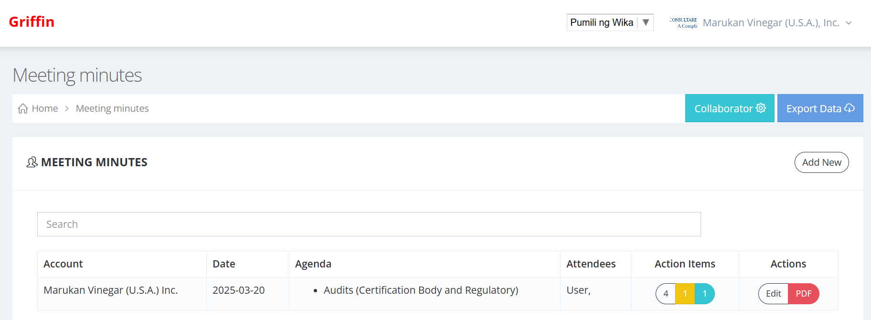
9 | Paramount Switch Account | Failed | Updates made in the Main Switch Account has been reflected to Paramount Switch Account | 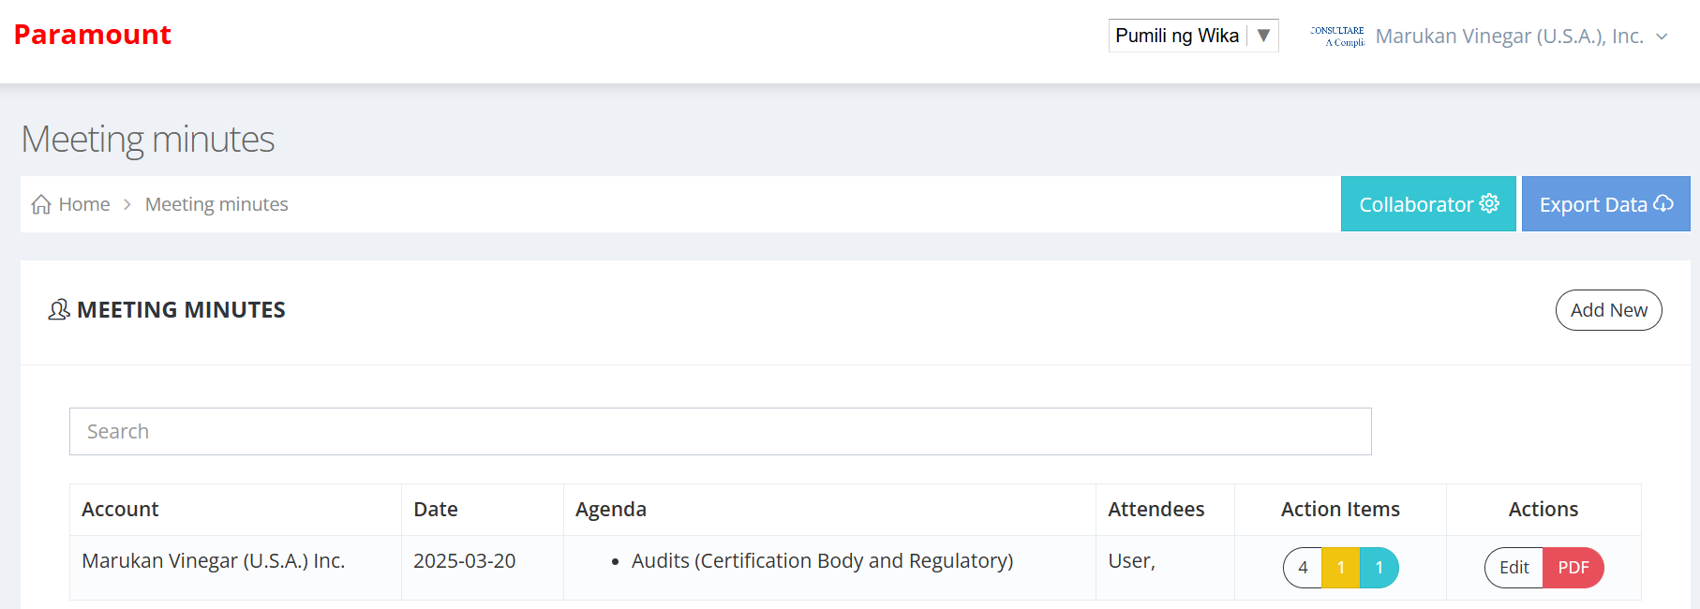

QA Test Performed by:
Debbie M. Abangan (March 20, 2025)

